INTRODUCTION:

1.1 Overview: A brief description about your project

1.2 Purpose: The use of this project. What can be achieved using this problem Definition & Design Thinking.

PROJECT TITLE:

Unearthing the Environmental Impact of Human Activity:
A Global CO2 Emission Analysis Global warming is one of the biggest challenges currently being faced by the human race, although correlation is not causation, a likely cause of Global warming is due to increased atmospheric carbon dioxide from human activities. CO2 Emission refers to the Carbon Dioxide emitted throughout the world. For this analysis we will be focusing on CO2 Emissions and its effect on the world we live in as well as some key factors and stats that may play a role in the emission of CO2 globally. Fossil fuel use is the primary source of CO2. The data throws light onto how much fossil fuels are burnt, per year per nation, which amounts to an increase in CO2 every year. This will help researchers and environment experts to predict global warming. So countries should set a goal to decrease this amount yearly. Analysing Global Co2 Emission across countries from 1975 to 2020. This dataset contains a record of Co2 Emission by each Country and Region of Earth, here we are going to analyse and visualise Country wise, Region wise and Overall Co2 Emission on Earth.



Co2 Emissions effets:

Exposure to CO2 can produce a variety of health effects. These may include headaches, dizziness, restlessness, a tingling or pins or needles feeling, difficulty breathing, sweating, tiredness, increased heart rate, elevated blood pressure, coma, asphyxia, and convulsions.

The average human exhales about 2.3 pounds of carbon dioxide on an average day. (The exact quantity depends on your activity level—a person engaged in vigorous exercise produces up to eight times as much CO2 as his sedentary brethren.)

DASHBOARD: 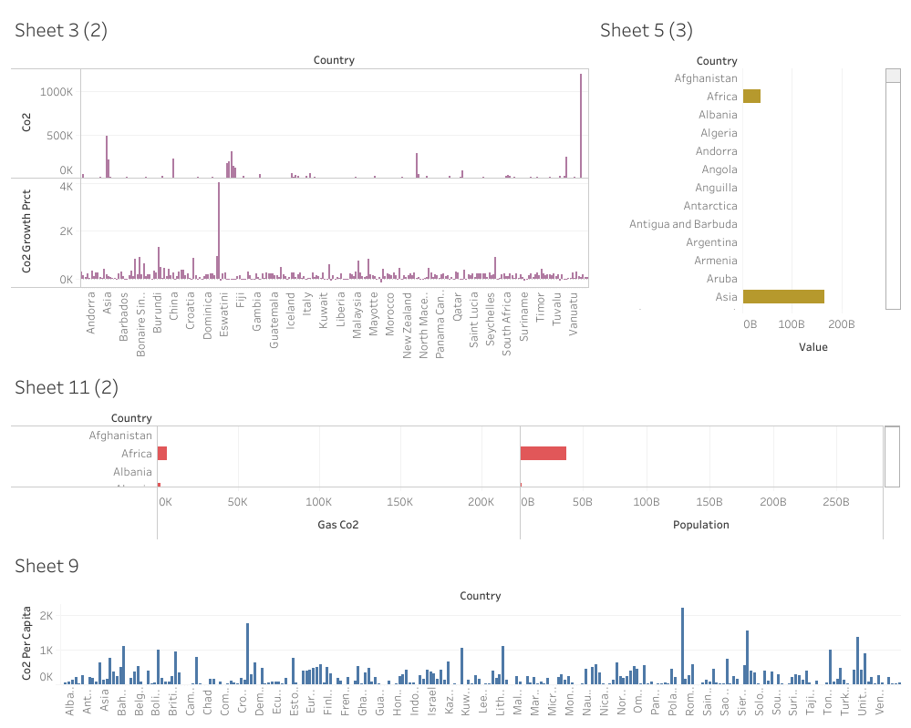

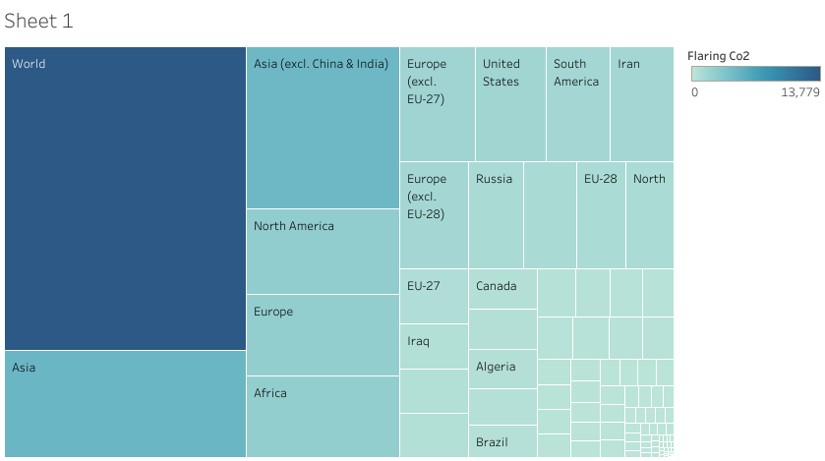

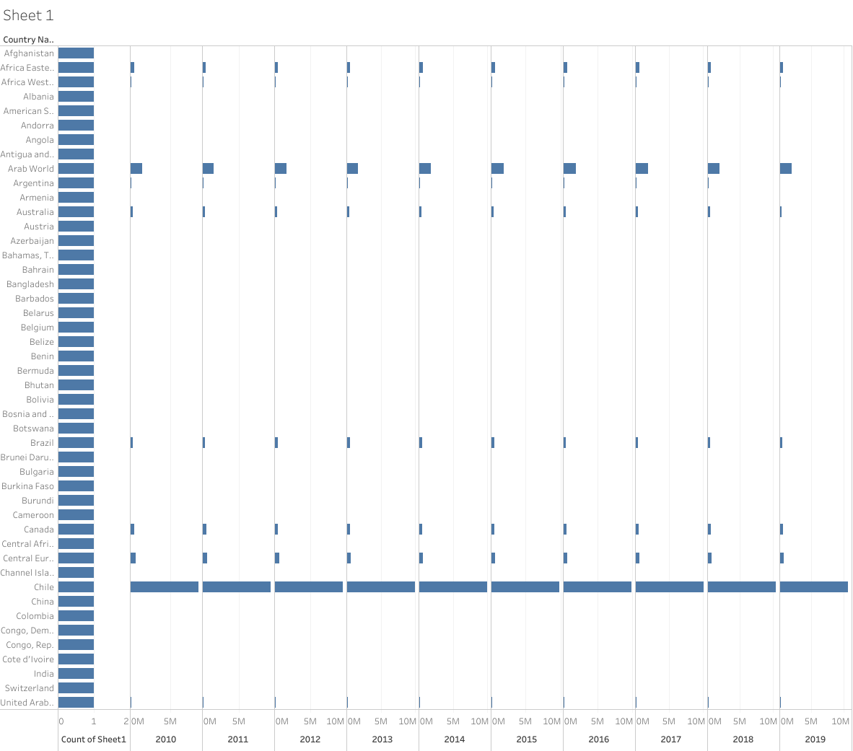

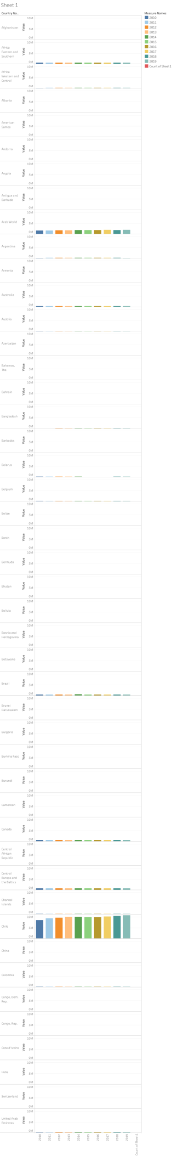

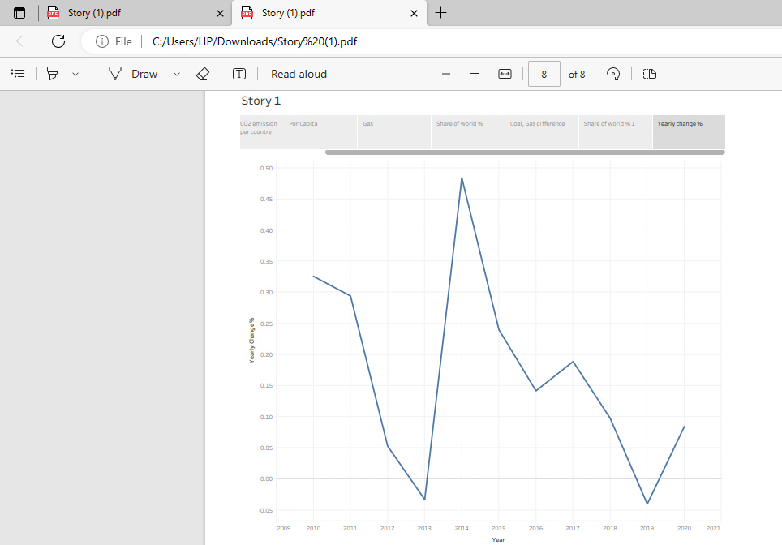


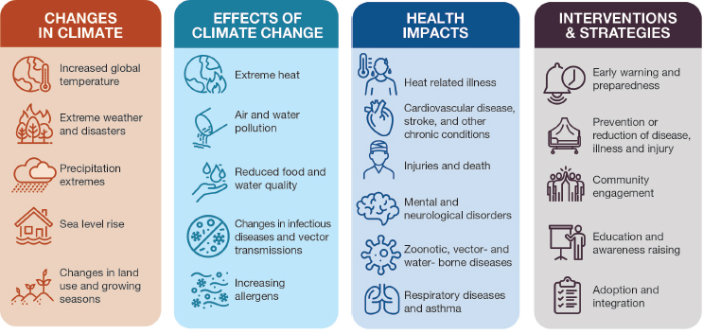
IMPACTS OF CO2 EMISSIONS:
- Climate change affects air
- quality, which in turn can lead to adverse health outcomes.
- Disruptions to weather patterns influence our air quality by increasing and distributing air pollutants, such as ground-level ozone, fine particulates, wildfire smoke, and dust.
- Changes to weather seasons also impact the production, distribution, and severity of airborne allergens.
- The EPA’s Air Quality National Summary Report states that around 100 million people living in the U.S.
- reside in communities where air pollution exceeds health-based air quality standards 1 .
- While primarily affecting outdoor air quality, these pollutants and allergens can also impair indoor air quality by entering homes, schools, and buildings.
- Additionally, climate change may contribute to the increased prevalence of indoor pollutants like mold. 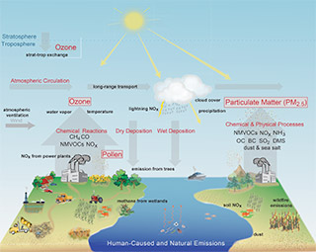









BRIEF DESCRIPTION ABOUT PROJECT:

Asset Quality:
1. What accounts for about 80% of human caused CO2 emissions?
Most CO₂ emissions (92%) are from the use of fossil fuels, especially for generation of electricity and heat, transportation, and manufacturing and consumption. Land use, land-use change and forestry is another contributor (3.7%) to human-made CO₂ emissions, mostly due to deforestation

2. What are human emissions of carbon?
Carbon Dioxide Emissions: Human Sources
Since the Industrial Revolution, human sources of carbon dioxide emissions have been growing. Human activities such as the burning of oil, coal and gas, as well as deforestation are the primary cause of the increased carbon dioxide concentrations in the atmosphere.

3. The most common gas poisonings that cause toxicity in our daily life are carbon monoxide and carbon dioxide poisoning, poisoning by insecticides and general everyday products [1]. Carbon monoxide (CO) is a poisonous gas that is generally released during incomplete combustion.
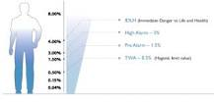
?

The Risks with CO
For humans even a small increase of CO₂ in the air is dangerous. Normal outdoor air has an average CO₂ percentage of just 0.04%. At 1,5 % CO₂ content humans reacts by increased heart rate and at 4 % CO₂ there is an Immediate Danger to Life and Health (IDLH).

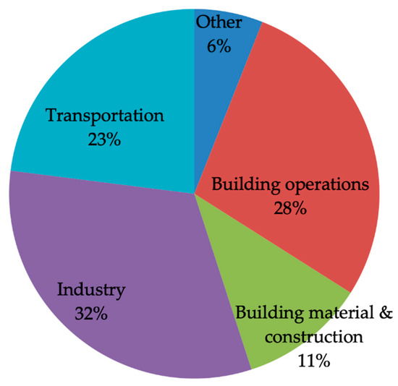

CONSEQUENCES OF THE GREENHOUSE EFFECT
- Thawing of glacial masses. ...
- Flooding of islands and coastal cities. ...
- Hurricanes will be more devastating. ...
- Migration of species. ...
- Desertification of fertile areas. ...
- Impact on agriculture and livestock.

Effects of Climate Change
- Hotter temperatures. As greenhouse gas concentrations rise, so does the global surface temperature. ...
- More severe storms. ...
- Increased drought. ...
- A warming, rising ocean. ...
- Loss of species. ...
- Not enough food. ...
- More health risks. ...
- Poverty and displacement.

Global warming can result in many serious alterations to the environment, eventually impacting human health. It can also cause a rise in sea level, leading to the loss of coastal land, a change in precipitation patterns, increased risks of droughts and floods, and threats to biodiversity.

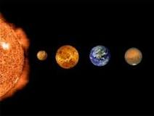
The greenhouse effect is the way in which heat is trapped close to Earth's surface by “greenhouse gases.” These heat-trapping gases can be thought of as a blanket wrapped around Earth, keeping the planet toastier than it would be without them.

Earth Will Continue to Warm and the Effects Will Be Profound
The potential future effects of global climate change include more frequent wildfires, longer periods of drought in some regions, and an increase in the duration and intensity of tropical storms.

Carbon dioxide in the atmosphere warms the planet, causing climate change. Human activities have raised the atmosphere's carbon dioxide content by 50% in less than 200 years.
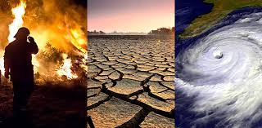
HARMFUL EFFECTS:
Carbon dioxide can be very harmful because it can form smog. It doesn't allow the reflected heat from the Earth to escape according to the Green House Effect. In small carbon dioxide is good as some amount of heat is needed for life to continue on Earth but, too much of it will cause global warming.

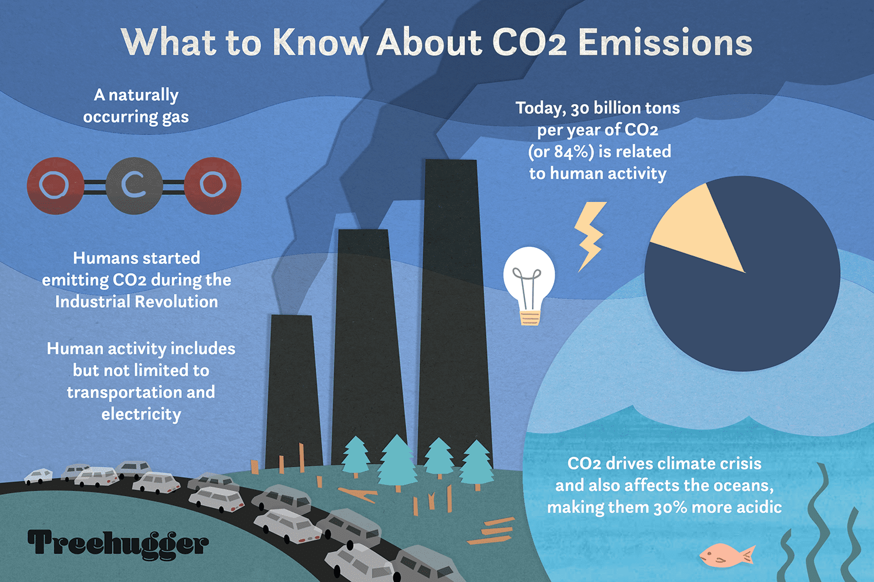
CAUSES:

Exposure to CO2 can produce a variety of health effects. These may include headaches, dizziness, restlessness, a tingling or pins or needles feeling, difficulty breathing, sweating, tiredness, increased heart rate, elevated blood pressure, coma, asphyxia, and convulsions.

The levels of CO2 in the air and potential health problems are:

- 400 ppm: average outdoor air level.
- 400–1,000 ppm: typical level found in occupied spaces with good air exchange.
- 1,000–2,000 ppm: level associated with complaints of drowsiness and poor air.
- 2,000–5,000 ppm: level associated with headaches, sleepiness, and stagnant, stale, stuffy air. Poor concentration, loss of attention, increased heart rate and slight nausea may also be present.
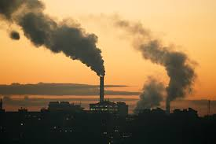
- 5,000 ppm: this indicates unusual air conditions where high levels of other gases could also be present. Toxicity or oxygen deprivation could occur. This is the permissible exposure limit for daily work place exposures.
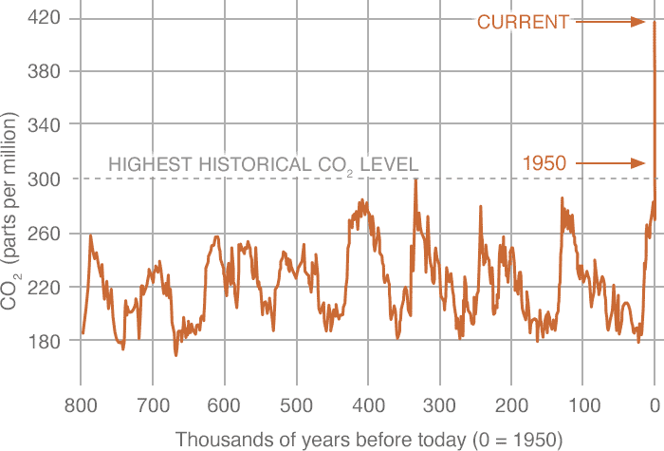
- 40,000 ppm: this level is immediately harmful d ue to oxygen deprivation

RESULT:
- co2 is one of the toxic gas.
- co2 increase the earth temperature and so global warming.
- increase in percentage of co2 in air causes melting of snow and hence their are increase in sea water co2 is one of the toxic gas.
- co2 increase the earth temperature and so global warming.
- increase in percentage of co2 in air causes melting of snow and hence their are increase in sea water level.

Conclusion:
        - In conclusion, we are knowledge to reduce the co2 emissions, in this wa How can it reduce CO2 emissions?
        - Top tips to reduce your carbon emissions
        - Use heating controls. For most of us, the first step in cutting carbon emissions it to take control of our heating. ...
        - Upgrade your heating system. ...
        - Insulate your home. ...
        - Draught-proofing. ...
        - Low energy lighting. ...
        - Energy efficient appliances. ...
        - Low carbon travel. ...
        - Reduce, reuse, recycle.

